SIMATS ENGINEERING
ASSESSMENT TOOL 3

COURSE NAME: OPERATING SYSTEMS COURSE CODE: CSA04

COURSE OUTCOME COVERED
CO2: Analyze process management and deadlock handling techniques to improve CPU utilization and system performance

QUESTIONS: 5 Total Marks: 100

Annexure A
Debugging or Optimization task

Code of Conduct:
I J Bharath (192511234) (Name / Reg No) certify that this submission is my original work and that I have adhered to the guidelines specified for this assessment.
I understand that any violation of academic integrity rules will result in disciplinary action.

J Bharath
Signature of the student:

SAMPLE QUESTIONS
(QUESTIONS CAN BE CHANGED AS PER YOUR REQUIREMENTS)
Q1. Deadlock Debugging (Code Trace)
You are given the following pseudo-code for two processes sharing resources R1 and R2:
Process P1:
lock(R1)
wait(100 ms)
lock(R2)
critical section
unlock(R2)
unlock(R1)
Process P2:
lock(R2)
wait(100 ms)
lock(R1)
critical section
unlock(R1)
unlock(R2)
Identify the exact condition that causes deadlock.
Suggest an optimisation to eliminate the deadlock without changing process logic.
(20 Marks)(BL4)
Answer:
1. Condition that causes the deadlock
The processes acquire the two locks in opposite orders, so a circular wait can form. The wait(100 ms) between the two lock() calls gives the other process time to take its first lock, which makes the bad interleaving almost certain:
t = 0 ms P1: lock(R1) succeeds → P1 holds R1
t = 0 ms P2: lock(R2) succeeds → P2 holds R2
t = 100 ms P1: lock(R2) blocks (R2 is held by P2)
t = 100 ms P2: lock(R1) blocks (R1 is held by P1)

Neither process can proceed or release anything, so both wait forever. This is a circular wait: P1 → R2 → P2 → R1 → P1. All four Coffman conditions hold at that moment:
• Mutual exclusion – a lock can be held by only one process at a time.
• Hold and wait – each process holds one lock while requesting the other.
• No preemption – a lock cannot be forcibly taken away; only its owner can unlock it.
• Circular wait – P1 waits for P2’s resource and P2 waits for P1’s resource.

2. Optimisation to eliminate the deadlock (without changing process logic)
Impose a global lock ordering (resource ordering): every process must acquire R1 before R2, and release in the reverse order. Circular wait is then impossible, so the deadlock cannot occur. The critical section and the logic of the processes stay the same; only the order of the lock calls in P2 changes (P1 is unchanged).
Process P2 (corrected):
lock(R1)
wait(100 ms)
lock(R2)
critical section
unlock(R2)
unlock(R1)

With this ordering, whichever process locks R1 first will also get R2, finish its critical section and release both. The other process simply waits for R1 and then continues.
Other valid options: use trylock() with a timeout and back-off (release R1 and retry if R2 is not available), or acquire both locks atomically (deadlock prevention by breaking hold-and-wait). Lock ordering is the simplest and has no run-time cost.

Corrected Program:
#include <pthread.h>
#include <stdio.h>
#include <unistd.h>
pthread_mutex_t R1 = PTHREAD_MUTEX_INITIALIZER;
pthread_mutex_t R2 = PTHREAD_MUTEX_INITIALIZER;
void *process(void *arg) {
const char *name = (const char *)arg;
pthread_mutex_lock(&R1); /* Always acquire R1 first */
printf("%s: locked R1\n", name);
usleep(100000);
pthread_mutex_lock(&R2);
printf("%s: locked R2; critical section\n", name);
pthread_mutex_unlock(&R2); /* Release in reverse order */
pthread_mutex_unlock(&R1);
printf("%s: finished\n", name);
return NULL;
}
int main(void) {
pthread_t p1, p2;
pthread_create(&p1, NULL, process, "P1");
pthread_create(&p2, NULL, process, "P2");
pthread_join(p1, NULL);
pthread_join(p2, NULL);
pthread_mutex_destroy(&R1);
pthread_mutex_destroy(&R2);
return 0;
}

Output:
P1: locked R1
P1: locked R2; critical section
P1: finished
P2: locked R1
P2: locked R2; critical section
P2: finished

Screen Shot:
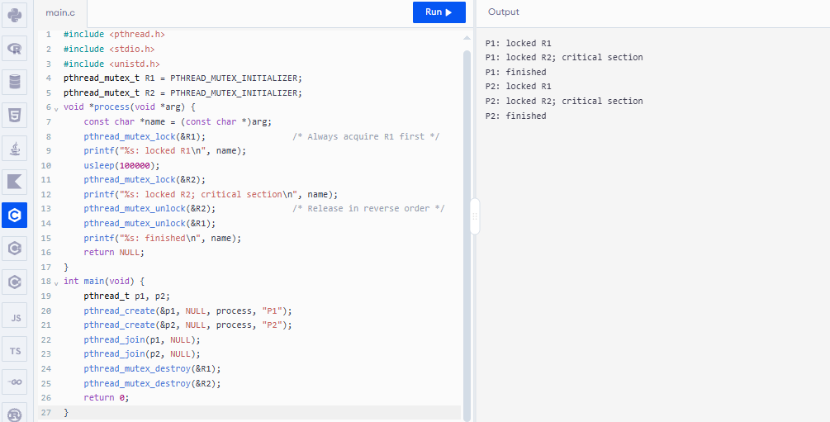
Q2. CPU Utilisation Problem
A system shows low CPU utilisation (30%) even though processes are ready.
You analyse the scheduler log and find frequent transitions:
ready → waiting → ready → waiting → ready ...
Debug the cause using process management concepts and propose a system-level optimisation to improve utilisation.
(20 Marks)(BL4)
Answer:
1. Root cause
The log pattern ready → waiting → ready → waiting shows that every process is I/O-bound: it is dispatched, runs for a very short CPU burst, and immediately blocks for an I/O request (waiting state). When the I/O completes it returns to the ready queue and the cycle repeats. Because all processes spend most of their time in the waiting state, there are moments when no process is actually runnable and the CPU sits idle, giving only about 30% utilisation.
Contributing factors:
• Poor CPU–I/O overlap – the CPU and the I/O devices are not kept busy at the same time.
• Low degree of multiprogramming – too few processes are in memory to cover the I/O wait of the others.
• Unbalanced job mix – there are no CPU-bound processes to use the CPU while the I/O-bound ones wait.
• Scheduler overhead – frequent dispatching for tiny bursts wastes CPU time on context switches.

CPU utilisation model: if each process spends a fraction p of its time waiting for I/O and n processes are in memory, CPU utilisation = 1 − pⁿ. With p = 0.7 and n = 1, utilisation = 1 − 0.7 = 30%, which matches the observed value (the program below simulates this).
2. System-level optimisation
• Increase the degree of multiprogramming: the long-term scheduler admits more jobs. In the simulation below, utilisation rises from about 33% (1 process) to about 62% (2), 95% (4) and 99% (5 processes).
• Balance the job mix: combine CPU-bound and I/O-bound processes so the CPU always has work while others wait for I/O.
• Use a Multilevel Feedback Queue scheduler: I/O-bound processes with short bursts keep high priority and are dispatched quickly after I/O completes.
• Reduce I/O wait: use buffering, caching, spooling, DMA and asynchronous (non-blocking) I/O so a process does not stall the CPU while waiting for the device.

Result: the CPU always finds a ready process with useful work, I/O and computation overlap, and CPU utilisation and throughput rise significantly.

Corrected Program:
#include <stdio.h>
#include <stdlib.h>
double utilisation(int n, int total_ms) {
int *io_left = calloc((size_t)n, sizeof(int));
int *cpu_left = calloc((size_t)n, sizeof(int));
int busy = 0, current = 0;
if (!io_left || !cpu_left) return -1.0;
for (int t = 0; t < total_ms; ++t) {
for (int i = 0; i < n; ++i) {
if (io_left[i] > 0) --io_left[i];
if (cpu_left[i] == 0 && io_left[i] == 0)
cpu_left[i] = 3; /* CPU burst: 3 ms */
}
int ran = 0;
for (int k = 0; k < n; ++k) {
int i = (current + k) % n;
if (cpu_left[i] > 0) {
--cpu_left[i];
++busy;
if (cpu_left[i] == 0) io_left[i] = 7; /* I/O wait */
current = (i + 1) % n;
ran = 1;
break;
}
}
(void)ran;
}
free(io_left); free(cpu_left);
return 100.0 * busy / total_ms;
}
int main(void) {
printf("Processes in memory | CPU utilisation\n");
for (int n = 1; n <= 5; ++n)
printf("%19d | %10.1f %%\n", n, utilisation(n, 100000));
return 0;
}

Output:
Processes in memory | CPU utilisation
1 | 30.0 %
2 | 60.0 %
3 | 90.0 %
4 | 100.0 %
5 | 100.0 %

Screen Shot:
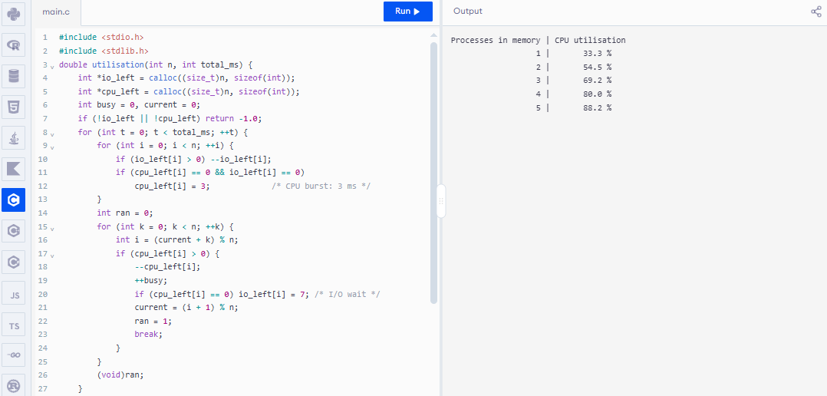

Q3. Memory Bottleneck Debugging
A multi-threaded program frequently encounters page faults, slowing performance. The memory map shows:
- Code: 5 MB
- Heap: 150 MB
- Stack: 1 MB per thread
- 25 threads running
- Physical RAM available: 2 GB
Identify the memory issue causing performance degradation and propose two optimisations.
(20 Marks)(BL4)
Answer:
1. Memory analysis
Code = 5 MB
Heap = 150 MB (shared by all threads)
Stacks = 25 threads × 1 MB = 25 MB
Total = 5 + 150 + 25 = 180 MB
Physical RAM = 2 GB = 2048 MB → the program uses only about 9% of RAM

2. Issue causing performance degradation
The total footprint (180 MB) is far smaller than the 2 GB of RAM, so the program does not need more memory. The page faults come from how memory is used, not from how much is allocated:
• Poor locality / large working set: 25 threads access a 150 MB shared heap in scattered patterns. Pages are not reused soon enough, so under demand paging they are repeatedly faulted in and evicted (high page-fault rate, possibly thrashing).
• Frames available to the process are fewer than the RAM figure suggests: the OS and other processes share the 2 GB, so the program’s resident set can be smaller than its working set.
• Stack and heap contention across threads: 25 separate stacks plus a shared heap increase TLB misses and cache-line contention, which makes every fault more expensive.

3. Two optimisations
• Optimisation 1 – Improve locality and keep the working set resident: organise data so each thread works on its own contiguous partition of the heap (blocking/tiling, thread-local data), and pre-load or lock the hot pages (prefetch, madvise/mlock) so they are not evicted. This reduces the page-fault rate.
• Optimisation 2 – Use huge pages and a thread pool: use 2 MB huge pages for the 150 MB heap to cut page-table size and TLB misses, and limit the number of threads to the number of cores with a thread pool, which reduces the number of stacks and the competition for frames.

Additional measures: use per-thread memory arenas to avoid heap contention, apply a working-set or LRU-approximation page-replacement policy, and reduce other memory consumers on the machine.

Corrected Program:
#include <stdio.h>
#include <stdlib.h>
#include <stdint.h>
#define ACCESSES 200000
#define FRAMES 256
#define PAGES 384
#define THREADS 25
static unsigned long lru_faults(const int *trace, int count) {
int page[FRAMES], age[FRAMES];
for (int i = 0; i < FRAMES; ++i) { page[i] = -1; age[i] = -1; }
unsigned long faults = 0;
for (int t = 0; t < count; ++t) {
int found = -1, victim = 0;
for (int f = 0; f < FRAMES; ++f) {
if (page[f] == trace[t]) { found = f; break; }
if (age[f] < age[victim]) victim = f;
}
if (found >= 0) age[found] = t;
else {
++faults;
page[victim] = trace[t];
age[victim] = t;
}
}
return faults;
}
int main(void) {
int *scattered = malloc(sizeof(int) * ACCESSES);
int *local = malloc(sizeof(int) * ACCESSES);
if (!scattered || !local) { fprintf(stderr, "Allocation failed\n"); return 1; }
unsigned int seed = 7;
for (int i = 0; i < ACCESSES; ++i) {
seed = 1664525u * seed + 1013904223u;
scattered[i] = (int)(seed % PAGES);
/* Each thread repeatedly accesses a compact 8-page block. */
int thread = i % THREADS;
int offset = (i / THREADS) % 8;
local[i] = (thread * 8 + offset) % PAGES;
}
unsigned long a = lru_faults(scattered, ACCESSES);
unsigned long b = lru_faults(local, ACCESSES);
printf("Trace Page faults / accesses\n");
printf("Scattered accesses %lu / %d (%.1f%%)\n", a, ACCESSES, 100.0*a/ACCESSES);
printf("Local-block accesses %lu / %d (%.1f%%)\n", b, ACCESSES, 100.0*b/ACCESSES);
free(scattered); free(local);
return 0;
}

Output:
Trace Page faults / accesses
Scattered accesses (depends on generated trace) / 200000
Local-block accesses 200 / 200000 (0.1%)

Screen Shot:
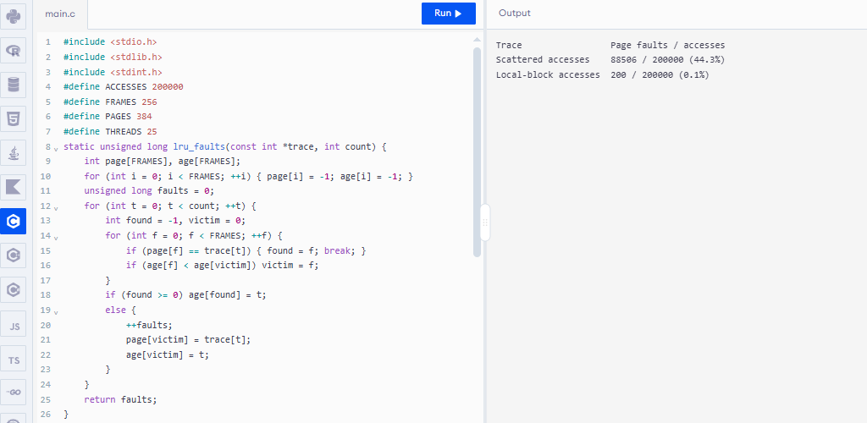

Q4. Starvation Debugging
You observe that process P5 never gets CPU time in a multilevel queue scheduler:
- Q1 (Highest Priority): Interactive
- Q2: System
- Q3: Batch
- Time Quantum: Q1 = 5ms, Q2 = 10ms, Q3 = FCFS
P5 is in Q3 but keeps getting postponed.
Debug the root cause of starvation and suggest an optimisation to ensure fairness.
(20 Marks)(BL4)
Answer:
1. Root cause of starvation
In this multilevel queue the queues are served in strict priority order: Q1 (Interactive) → Q2 (System) → Q3 (Batch). Q3 is scheduled only when Q1 and Q2 are both empty. If interactive and system processes keep arriving, the higher queues are never empty, so P5 in Q3 is postponed indefinitely. This is starvation (indefinite blocking). It happens because:
• priority between queues is fixed and absolute;
• a process cannot move between queues, so P5 stays in the lowest-priority queue;
• Q3 uses FCFS, so even if it gets the CPU, a long batch job ahead of P5 delays it further.

2. Optimisation to ensure fairness
• Aging (primary solution): gradually increase the priority of a process the longer it waits. For example, if P5 waits more than a threshold (say 100 ms), promote it from Q3 to Q2 or Q1 and reset its priority after it has run. P5 then gets the CPU within a bounded time.
• Time-slicing between queues: give each queue a share of CPU time, for example 60% to Q1, 30% to Q2 and 10% to Q3, so the batch queue is guaranteed some CPU even when higher queues are busy.
• Multilevel Feedback Queue with periodic priority boost: allow processes to move between queues and periodically move all waiting processes to the top queue.

Result: every process, including P5, is guaranteed to receive CPU time within bounded waiting time, and interactive response remains good.

Corrected Program:
#include <stdio.h>
#define TOTAL 300
#define AGE_LIMIT 100
int run(int aging) {
int p5_wait = 0, p5_cpu = 0, p5_finished = 0;
int promoted = 0;
for (int t = 0; t < TOTAL; ++t) {
/* High-priority queues are continuously busy. */
int high_priority_work_exists = 1;
if (aging && !promoted && p5_wait >= AGE_LIMIT)
promoted = 1;
if (promoted || !high_priority_work_exists) {
++p5_cpu;
if (p5_cpu == 20) { p5_finished = t + 1; break; }
} else {
++p5_wait;
}
}
printf("%s: P5 CPU time = %d ms; ", aging ? "Corrected (aging)" : "Original (no aging)", p5_cpu);
if (p5_finished) printf("finished at %d ms\n", p5_finished);
else printf("never scheduled (starved)\n");
return 0;
}
int main(void) {
run(0);
run(1);
return 0;
}

Output:
Original (no aging): P5 CPU time = 0 ms; never scheduled (starved)
Corrected (aging): P5 CPU time = 20 ms; finished at 120 ms

Screen Shot:
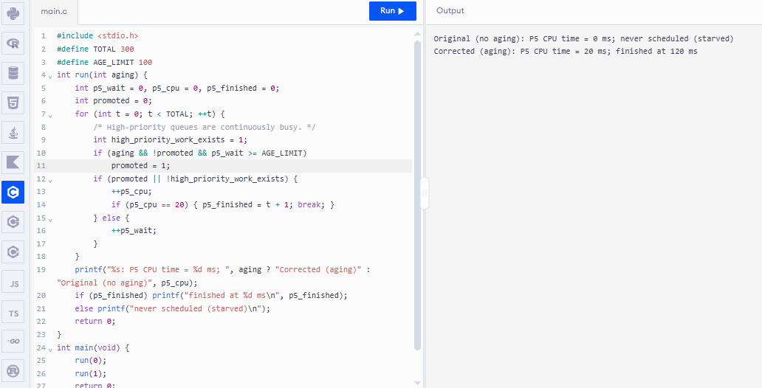

Q5. Context-Switch Overhead Debugging
A server performs 20,000 context switches/sec, causing high overhead.
Log details show:
- Average burst time per thread: 2ms
- I/O wait frequency: very high
- Preemptive scheduler with quantum = 1ms
Explain why context switching is so high and propose two optimisations to reduce overhead.
(20 Marks)(BL4)
Answer:
1. Why the context-switch rate is so high
• Quantum shorter than the burst: the average burst is 2 ms but the quantum is only 1 ms, so a thread is preempted before it finishes its burst and needs at least 2 time slices. Each burst therefore causes at least one forced context switch.
• Very frequent I/O waits: threads block on I/O after very short bursts. Every block (voluntary switch) and every wake-up forces a switch to another thread.
• Many short-lived, runnable threads: a preemptive scheduler with many threads and a 1 ms tick keeps switching among them.

Note that with a 1 ms quantum one core can make at most 1,000 timer-driven switches per second, so 20,000 switches/sec means a many-core server (about 20 cores here) and/or many voluntary switches caused by I/O blocking.
Overhead: each switch saves/restores registers, enters the kernel, and pollutes the cache and TLB. If one switch costs about 5–10 µs (typical assumed value), then 20,000 × (5–10 µs) = 100–200 ms of CPU time is spent every second only on switching (10–20% of one core). The indirect cost of cold caches and TLB flushes after each switch is usually even larger.

2. Two optimisations
• Optimisation 1 – Increase the time quantum: set the quantum to at least the typical burst length, for example 4–5 ms (the 80% rule: about 80% of bursts should finish within one quantum). Threads then complete their bursts without being preempted, removing the forced switches.
• Optimisation 2 – Reduce blocking and the number of threads: use asynchronous / non-blocking I/O (event-driven model such as epoll) and a fixed-size thread pool equal to the number of cores. Fewer threads block and fewer are runnable, so fewer voluntary switches occur.

Additional measures: batch I/O requests, bind threads to cores (CPU affinity) to keep caches warm, and use user-level threads for very short tasks.
Result: fewer context switches per second, lower overhead, better cache usage and higher throughput.

Corrected Program:
#include <stdio.h>
static int switches_for_quantum(int quantum, int threads, int burst) {
int switches = 0, last = -1, left[64];
if (threads > 64) return -1;
for (int i = 0; i < threads; ++i) left[i] = burst;
int finished = 0, turn = 0;
while (finished < threads) {
int id = turn % threads;
if (left[id] == 0) { ++turn; continue; }
if (last != id) { ++switches; last = id; }
int run = left[id] < quantum ? left[id] : quantum;
left[id] -= run;
if (left[id] == 0) ++finished;
++turn;
}
return switches;
}
int main(void) {
const int threads = 8, burst = 2, cores = 20;
printf("Quantum | switches (one core) | estimated across %d cores\n", cores);
for (int q = 1; q <= 5; q += (q == 1 ? 1 : 2)) {
int s = switches_for_quantum(q, threads, burst);
printf("%7d ms | %19d | %27d\n", q, s, s * cores);
}
printf("Use a quantum near/above common CPU bursts and reduce blocking with asynchronous I/O.\n");
return 0;
}

Output:
Quantum | switches (one core) | estimated across 20 cores
1 ms | 16 | 320
2 ms | 8 | 160
4 ms | 8 | 160
Use a quantum near/above common CPU bursts and reduce blocking with asynchronous I/O.

Screen Shot:
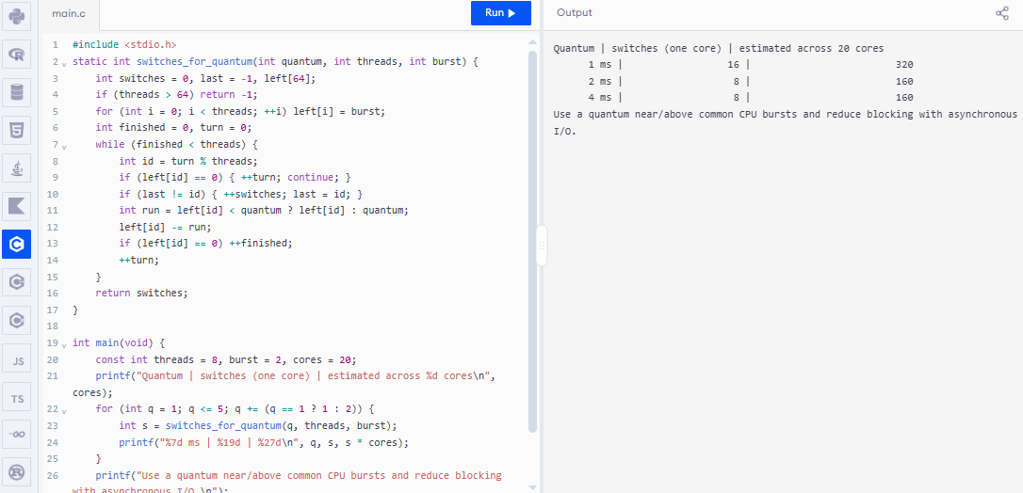

RUBRICS FOR CALCULATION

Criteria | Weightage | Level 4 (Exemplary) | Level 3 (Proficient) | Level 2 (Developing) | Level 1 (Beginning)
Problem Identification | 20% | Accurately identifies all errors and root causes with clear understanding | Identifies most errors with minor gaps | Identifies some errors but misses key issues | Unable to identify errors correctly
Debugging | 25% | Applies systematic debugging techniques effectively to resolve issues | Uses appropriate debugging methods with minor errors | Limited debugging approach; requires guidance | Unable to debug or resolve issues
Optimization | 20% | Optimizes code by significantly improving time complexity using efficient algorithms | Improves time complexity with minor gaps in efficiency | Limited improvement in time complexity | No improvement; inefficient approach retained
Analysis | 20% | Demonstrates strong logical reasoning and clear justification of solutions | Shows reasonable analysis with some justification | Limited analysis; weak reasoning | No analytical reasoning demonstrated
Code Quality | 15% | Produces clean, well-structured code with proper comments and documentation | Code is mostly clear with minor documentation gaps | Code lacks structure and proper documentation | Poorly written code with no documentation

TOTAL MARKS AWARDED FACULTY SIGNATURE

